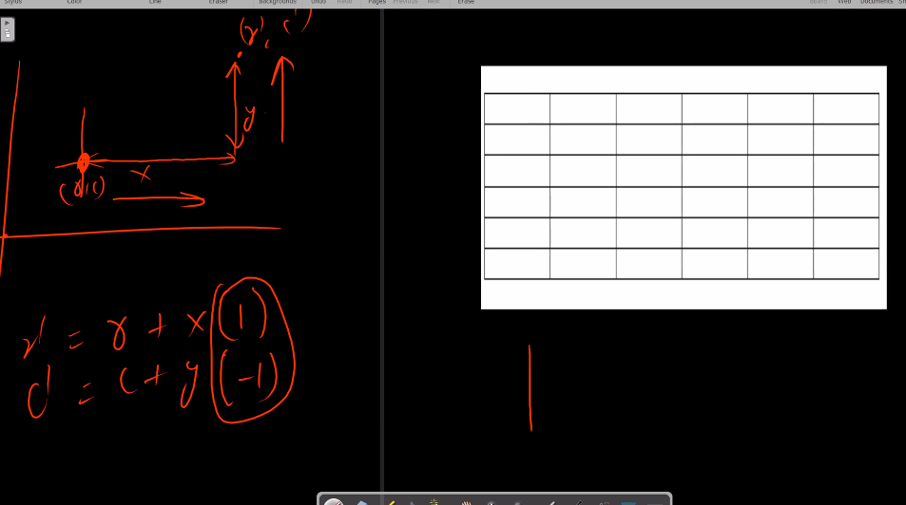

**FLOOD FILL QUESTION VARIATIONS**

**DFS ALGORITHM:-**

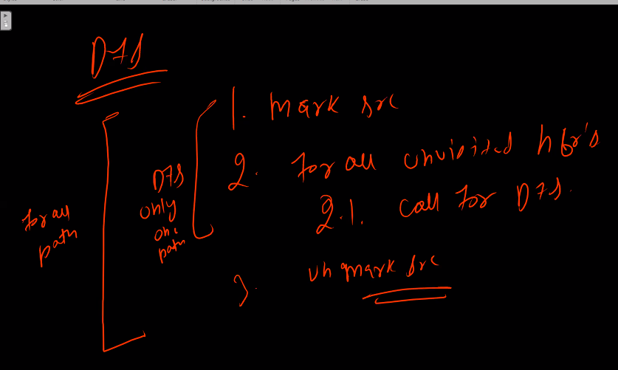

Flood fill

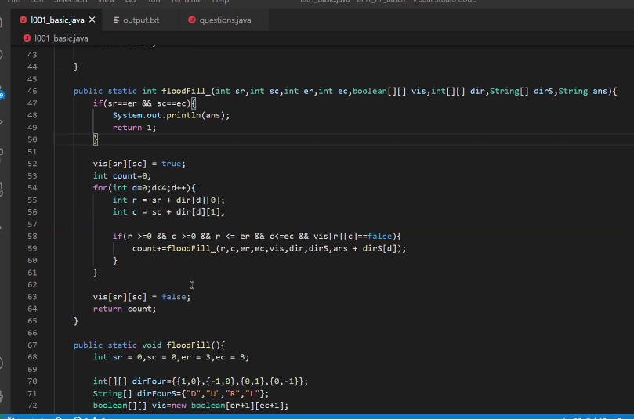

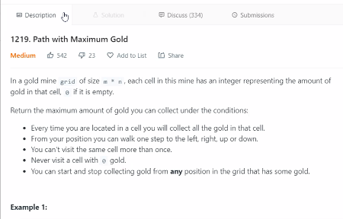

**1219**

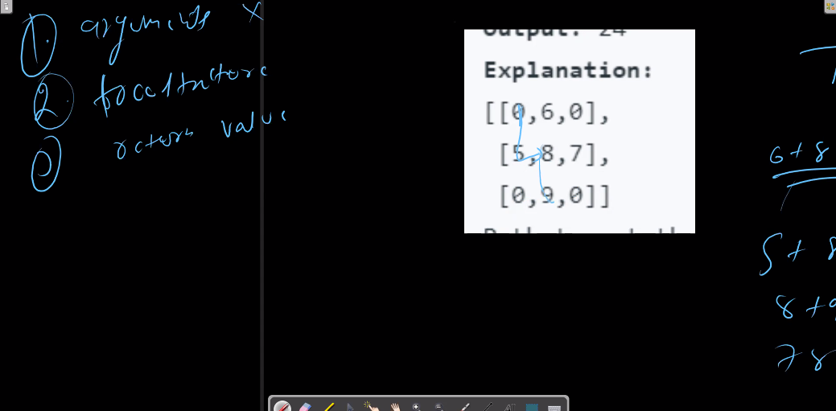

**Dhyaan rkhe ye goldmine vale mei ham dp memoizatoin vagerah nahi laga skte agar lagani bhi hai toh 3d dp lagani padgei because jaroori nahi hai ki jis node pe mai jaa rha hoo vo hamesha vahi doobara value de**

**980**

**Today’s problem 46-47-17-91**

**Problem’s with hashmaps**

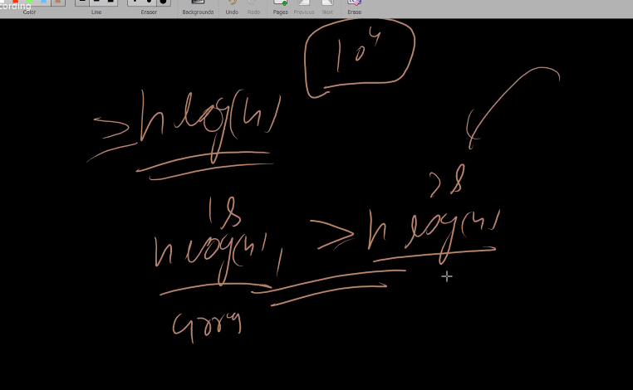

**Soln – for -47**

**Soln-for -17**

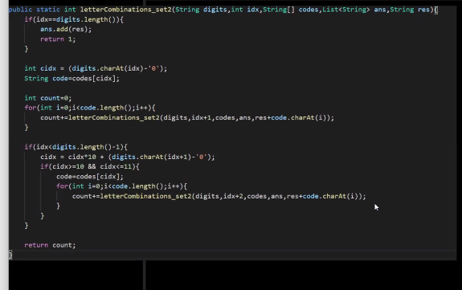

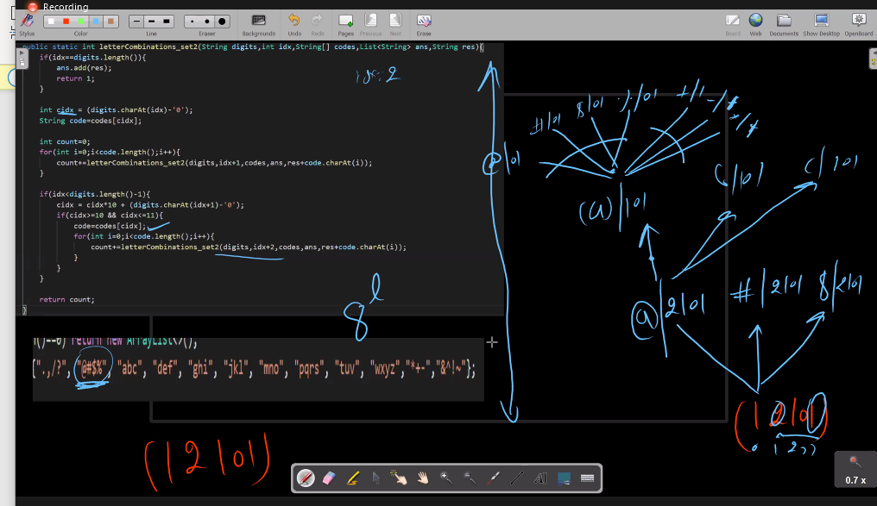

**Soln-91**

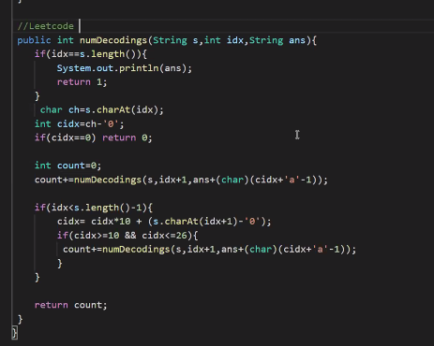

**RAJNEESH SIR DAY-3 RECURSION IMPORTANT PART**

**1-coin change permut infinite**

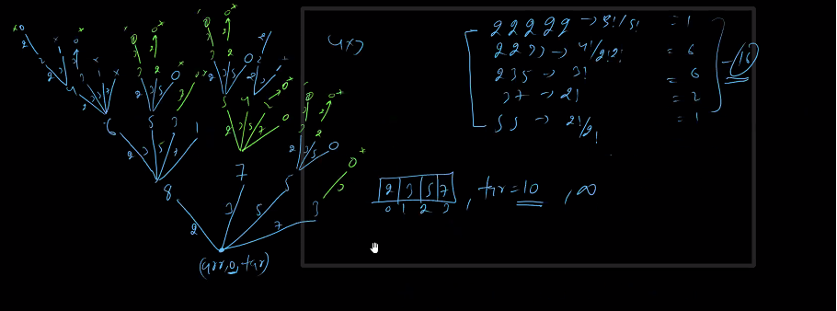

**Coin change single combin**

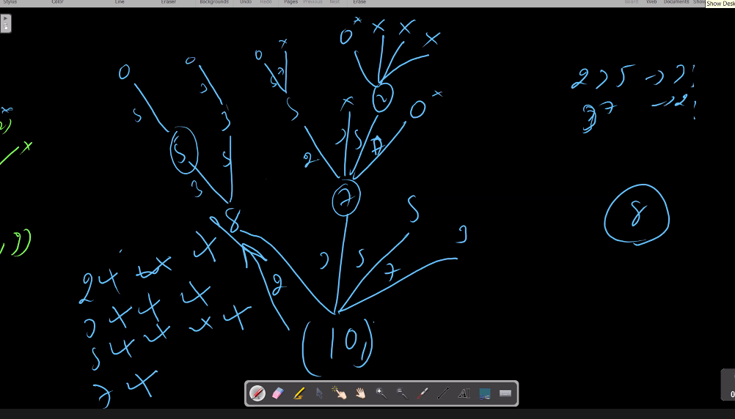

**Same que diff solution**

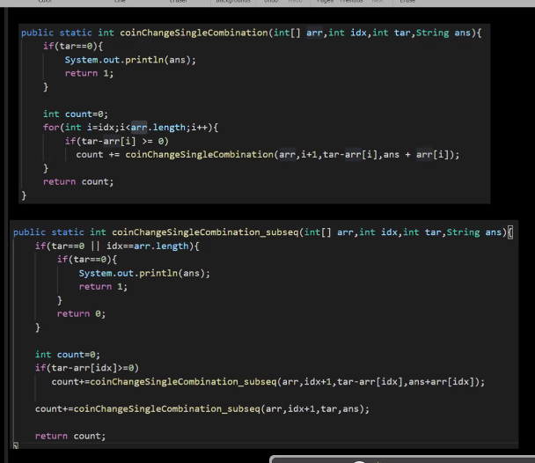

**Tree:-**

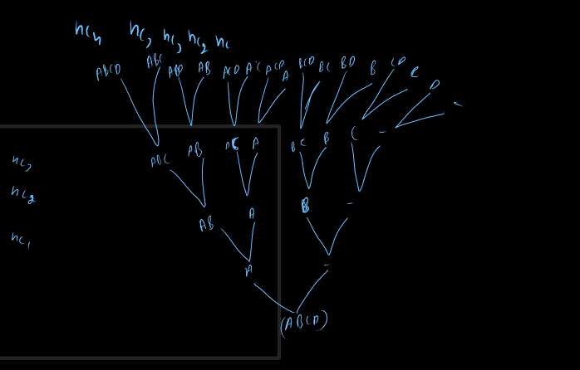

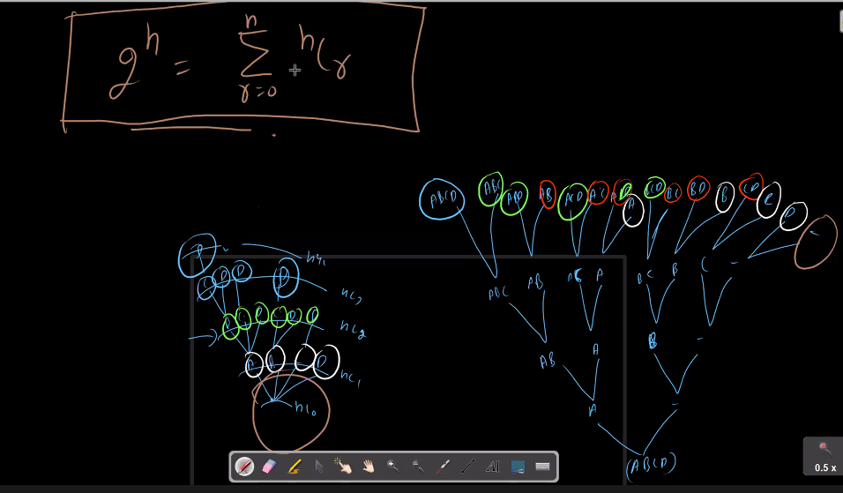

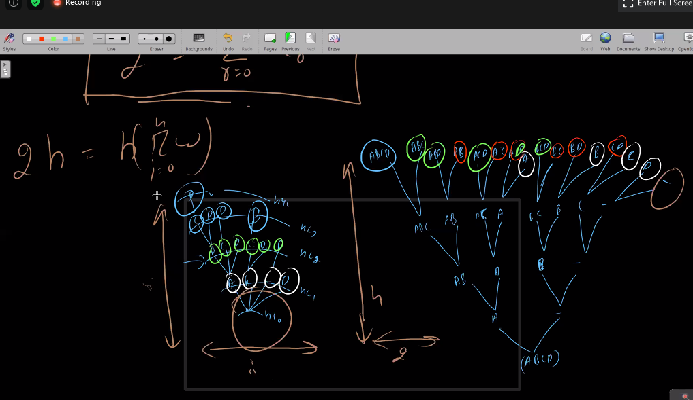

Is upar vale tree mei do code hai subseq vala and for loop vala par dono ki complexity same hogi farak bas tree depth or width ka hai that’s it or koi antar nahi hai

Ye neeceh vale dono trees bilkul same hai

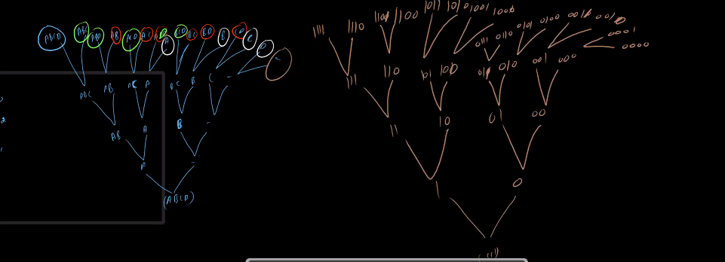

**39,40,77,216 ,90,**

